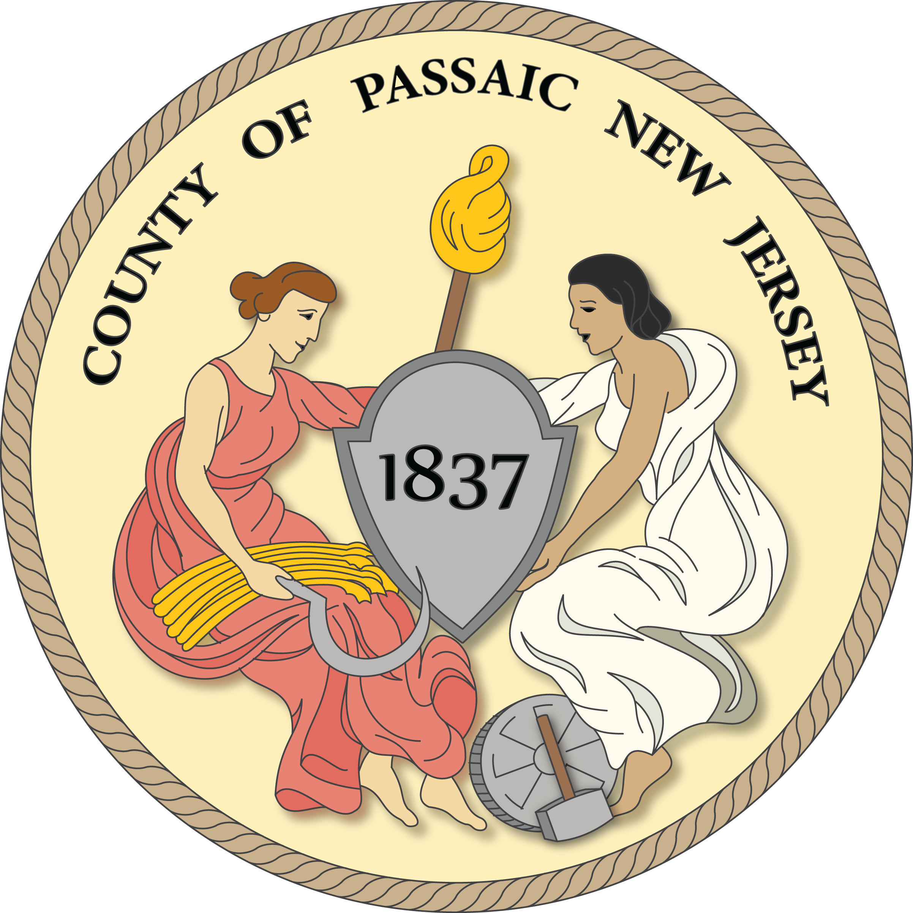

**DIG IN! BUDGET TEMPLATE FOR**

**WATER ASSISTANCE PROGRAM**

|  |  |  |  |
| --- | --- | --- | --- |
| Water System Equipment Expenses | QUANTITY | COST | TOTAL |
|  |  |  |  |
|  |  |  |  |
|  |  |  |  |
|  |  |  |  |
|  |  |  |  |
|  |  |  |  |
|  |  |  |  |
|  |  |  |  |
|  |  |  |  |
|  |  |  |  |
|  |  |  |  |
|  |  |  |  |
|  |  |  |  |
|  |  |  |  |
|  |  |  |  |
|  |  |  |  |
| TOTAL EXPENSES |  |  | $ |
|  |  |  |  |
| INCOME |  |  |  |
| Dig In Grant Requested |  |  | $ |
| Dig In Required 10% Grant Match | | | $ |
| Other (i.e. additional grant funding) | | | $ |
| TOTAL INCOME | | | $ |

**RETURN TO:** Kaitlin Muccio, New Ground Program Assistant, City Green Inc., 171 Grove Street, Clifton NJ 07013

Telephone: 973-869-4086, Email: kmuccio@city-green.orgFax: 973-998-0682